Specification
Pavements
REV 01/19

Delastic® Preformed Pavement Seals
Preformed Polychloroprene Compression Joint Seal

SECTION I – General
A. This specification covers the preformed polychloroprene (neoprene) compression joint seal of the open-cell compression type, intended for use in sealing joints in concrete pavements. It also covers the lubricant- adhesive used when installing the seal.

SECTION II – Composition and Manufacture
- The preformed polychloroprene (neoprene) compression joint seal shall be manufactured from a vulcanized elastomeric compound using polymerized chloroprene as the only base polymer. Polychloroprene shall make up at least 50% of the compound used in the manufacture of the seal.
- Acceptable manufacturers of the preformed polychloroprene (neoprene) compression joint seal and the appropriate model of seal shall be:
The D.S. Brown Company 300 East Cherry Street North Baltimore, OH 45872 Phone: (419) 257-3561
Models: “E” & “V” series or pre-approved equal determined by the engineer prior to bid time and date.

SECTION III – Size and Shape
- The shape of the joint seal shall include six individual cells for seals greater than .450 inches and less than
1.50 inches in nominal width. All other seals must have at least five individual cells.
- The following nominal width compression joint seals are typically recommended for the following joint width openings:
  - 7/16” nominal width seal for joints 1/4” wide
  - 9/16” nominal width seal for joints 5/16” wide
  - 11/16” nominal width seal for joints 3/8” to 15/32” wide
  - 13/16” nominal width seal for joints greater than 15/32” to 9/16” wide
  - 1” nominal width seal for joints greater than 1/2” to 5/8” wide
  - 1 1/4” nominal width seal for joints greater than 5/8” to 7/8” wide
  - 1 5/8” nominal width seal for joints greater than 7/8” to 1 1/8” wide
  - 2” nominal width seal for joints greater than 1 1/8” to 1 7/16” wide
  - 2 1/2” nominal width seal for joints greater than 1 7/16” to 1 13/16” wide
  - 3” nominal width seal for joints greater than 1 13/16” to 2 3/8” wide
- The material as delivered to the jobsite shall be accompanied by the manufacturer’s certification stating it meets all requirements of ASTM D2628. The owner will verify the certification prior to material installation. The owner also has the option to sample and test the material from the jobsite.

SECTION IV – Identification and Marking
A. The seals shall be marked with the name or a suitable trademark of the manufacturer, lot number and catalog number at intervals of less than 4 feet. Also, on the top surface of the seal, a mark shall be placed at every one- foot interval.

SECTION V – Physical Properties
- The material shall conform to USACE CRD-C 548 for jet fuel and heat resistance.
- The material shall conform to the physical properties prescribed below (ASTM D2628).

Bridge the World with Leading Infrastructure Solutions

2 of 3

Tensile Strength, min psi 2000 D412
Elongation at break, min % 250 D412
Hardness, Type A Durometer 55 ± 5 D2240 a*

Ozone Resistance D1149 b*
20% strain, 300 pphm, 70 hrs. @ 104°F no cracks
Low Temperature Recovery D2628-81
72 hrs. @ 14°F, under sctn 9.2
50% deflection, min. % 88
Low Temperature Recovery D2628-81 22 hrs. @ -20°F, under
50% deflection, min. % 83
High Temperature Recovery D2628-81
70 hrs. @ 212°F, under sctn 9.2
50% deflection, min. % 85

*a The use of joint seal as the specimen source requires that more plies than specified in the procedure be used.
*b Test in accordance with procedure A of D518.

SECTION VI – Sampling
A. A lot shall consist of no more than one manufacturer’s production day or 30,000 linear feet, whichever is less. Samples shall be taken at random from each lot to be shipped. A minimum of six linear feet shall constitute one sample for testing purposes.

SECTION VII – Testing
- Testing shall be completed on each lot by the manufacturer. Specimen preparation and testing shall follow the method explained in ASTM D2628.
- The manufacturer of the approved preformed polychloroprene (neoprene) compression joint seal material must provide documentation of supplying preformed polychloroprene (neoprene) compression joint seal that meets ASTM D2628 to 10 federal or state projects over the last 3 years.

SECTION VIII – Lubricant-Adhesive
- The lubricant-adhesive used to install the preformed polychloroprene (neoprene) compression joint seal shall be a one-component polychloroprene compound containing only soluble phenolic resins blended together
with antioxidants and acid acceptors in a suitable mixture of organic solvents. The lubricant-adhesive shall meet ASTM D2835 and shall have the following properties:
Solids Content 22 – 28%, by weight
Property Requirements ASTM Method
Viscosity shall be that the lubricant will perform suitably with the installation equipment.
Oven Aging, 70 hrs. @ 212°F Tensile strength, loss, max., % Elongation, loss, max., % Hardness, Type A, points change | 20 max.  20 max.  0 to +10 | D573
Oil Swell, ASTM Oil IRM 903 70 hrs @ 212°F  Weight change, max., % | 45 max. | D471

The lubricant shall remain fluid from 5° to 120°F.
The lubricant should be kept from freezing and used within 360 days of manufacture.

- Each lot of lubricant-adhesive shall be delivered in containers plainly marked with the manufacturer’s name and trademark, lot number and date of manufacture and shall be accompanied by the manufacturer’s certification as to conformance to this specification.

SECTION IX – Storage and Shipment
A. The preformed polychloroprene (neoprene) compression joint seal is delivered either in cardboard boxes or on wooden cable reels. The proper storage of the cardboard boxes requires that the boxes be protected from moisture to keep the cardboard from deteriorating. The large wooden cable reels should be covered by a tarpaulin to keep the seal clean and free of damage. The lubricant-adhesive shall be kept from freezing.

SECTION X – Joint Preparation
- To form the joint, a two-stage sawing operation shall be performed. The first sawcut shall be a minimum of 33% of the depth of the concrete. This cut shall be performed at the proper time to eliminate all random cracking. The second sawcut shall create the proper shape factor for the preformed polychloroprene (neoprene) compression joint seal. This sawcut will be made with a water-cooled diamond blade saw capable of holding a tolerance of ± 1/16”. The sawcut shall be inspected for proper width and depth, and the face of the joint must be at 90 degrees to the surface of the pavement.
- After the secondary sawcut is made, the joint shall immediately be pressure-washed with clean water and blown out with compressed air. Sandblasting will only be necessary if called for in the specification of the project.
- For joint reseal projects, it is important that the joint reservoir be constructed properly to accommodate the specified compression joint sealant. Joints may need to be re-cut prior to installation. The saw cutting and joint cleaning must be in accordance with manufacturer’s recommendations for the seal size being used.
- The joints must be clean and dry at time of seal installation.

SECTION XI – Installation
  - The installation machine should be capable of installing the seal at the specified depth without cutting, nicking or twisting the seal. The installation equipment must be approved by the seal manufacturer and accepted by the engineer prior to joint material installation. Hand installation is not acceptable as the primary installation method. The machine shall at all times be operated by an experienced
operator. Machines shall be provided, and support given, by the same entity that is manufacturing the sealant.
  - The lubricant-adhesive meeting ASTM D2835 is used mainly to facilitate the installation of the preformed polychloroprene (neoprene) compression joint seal. The lubricant-adhesive must contain a minimum of 22% solids, be uniform, contain no lumps, have the correct viscosity and have a drying time between eight and twenty minutes. The containers of lubricant-adhesive should be labeled with the manufacturer’s name, catalog number, lot number and manufacture date. Also, an SDS must accompany all shipments for the safety of the user. The lubricant-adhesive will begin to thicken at 40°F. When sealing operations occur where the air temperature falls below 40°F, the lubricant-adhesive must be stored in a heated warehouse until immediately prior to use. Please contact the preformed polychloroprene (neoprene) compression joint seal manufacturer if installing seal when temperatures are below 32°F.
  - The proper installation sequence for preformed polychloroprene (neoprene) compression joint seal is to install the longitudinal seal first. After allowing the glue to dry (approximately 20 minutes), the longitudinal seal is cut with a sharp instrument or saw blade at the middle of the intersection of the transverse joint. Initially, only make one single cut. The material should retract, leaving enough room for the transverse sealant. The transverse joint seal is then installed through the cut in the longitudinal seal to form a tight intersection. The transverse seal should be installed in one continuous piece. The transverse seal will exert outward force on
3 of 3

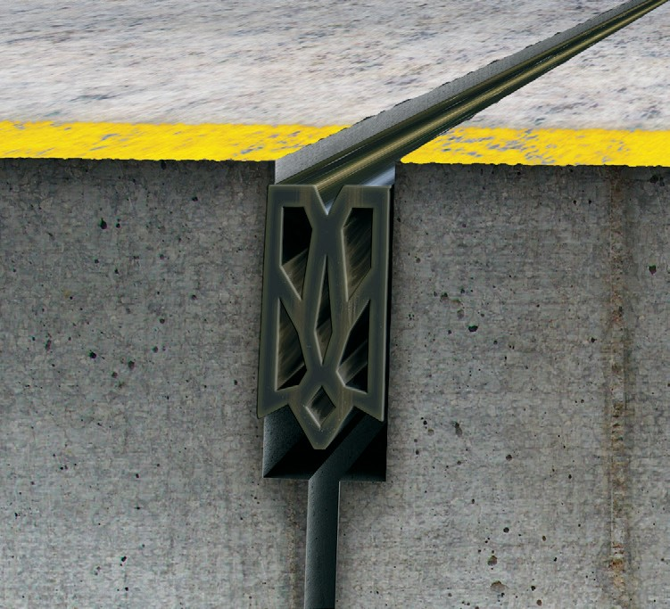
the cut end of the longitudinal seal to form a tight intersection.
  - Correcting Spalls: Some spall repair will be necessary, but for small spalls 5/8” wide or smaller and less than 3” long, use Sika 1A (Black), or Non Sag Silicone that meets ASTM D5893. As directed by the engineer, the liquid seal material will be used to fill in any small voids along the preformed polychloroprene (neoprene) compression joint seal and concrete joint wall. Spalls larger than 5/8” wide and 3” long shall be repaired with Delpatch™ Elastomeric Concrete manufactured by the D.S. Brown Company.

SECTION XII – Inspection
A. Stretching the seal during installation is the major cause of premature failure of the preformed polychloroprene (neoprene) compression joint seal. Inspecting for stretch should be done very early in the sealing process. The inspection involves loosely laying a piece of preformed polychloroprene (neoprene) compression joint seal the entire width of the pavement and cutting it at the exact width of the pavement. The seal is then installed in the joint. Any excess amount of seal remaining at the end of the joint is due to stretch. The length of this excess is measured and a stretch percentage is calculated by dividing the excess length by the original length. Stretch greater than 4% is unacceptable. The depth of the seal shall be .1875 inches (± .0625) below the surface of the pavement or, in the case of a chamfered joint, it should be .125 inches (± .0625) below the bottom of the chamfer. The seal shall not be twisted or have any deformity that interferes with the seal making complete contact with the joint face.

SECTION XIII – Manufacturer’s Technical Representative
A. A manufacturer’s technical representative of the preformed polychloroprene (neoprene) compression joint seal must be on site for the first two days during its installation.

